Mapping practical tools that facilitate the implementation of formal apprenticeship in the
Arab Republic of Egypt

‘Career Advisory and Consultancy Service’
Tool | Career Advisory and Consultancy Service
Tool focus | The tool aims at screening job-seekers for an apprenticeship opening at companies by reviewing the skills needs of the job seekers and the skills needs of companies and addressing the gap with targeted skills training
Target group | The tool is relevant for (i) job-seekers from disadvantages groups, including refugees and women; (ii) TVET institutions seeking to better match their trainees with the needs of companies; and (iii) companies that wish to engage in a dual apprenticeship programme.

The Programme: Implementing Apprenticeship Programme for Refugees and Host Communities
The apprenticeship programme is hosted at the Vocational Training and Employment Center (VTEC) of the Alexandria Business Association (ABA). It operates under a formal agreement between the ILO PROSPECTS partnership and VTEC Alexandria.
The Alexandria Business Association (ABA-VTEC) was founded in 2014 based on an agreement between the ABA and the northern command of the Egyptian Armed Forces to support slum communities in the Alexandria region, including refugees (mainly from Syria and Iraq) living in the region as well as women and girls. This means that the centre is strongly supported by the Egyptian government although it is a private sector-run centre. The below figure shows the multitude of training for skills development and employment offered by the ABA-VTEC.
The ABA-VTEC apprenticeship initiative builds on longstanding experiences of tailor-made and multifaceted programmes meeting the needs of both job-seekers and companies. The range of services provided by the VTEC are offered under the auspices of various ministries, such as the Egyptian Ministry of Education and Technical Education (MoETE) as well as agreements with the different stakeholders.
The project was implemented as part of the PROSPECTS programme supported by the embassy of the Netherlands in Egypt, the IFC, the ILO, UNHCR and UNICE.

Figure 1: An overview of the VTEC training and employment promotion, Source: Presentation of VTEC: VTEC Profile_2020
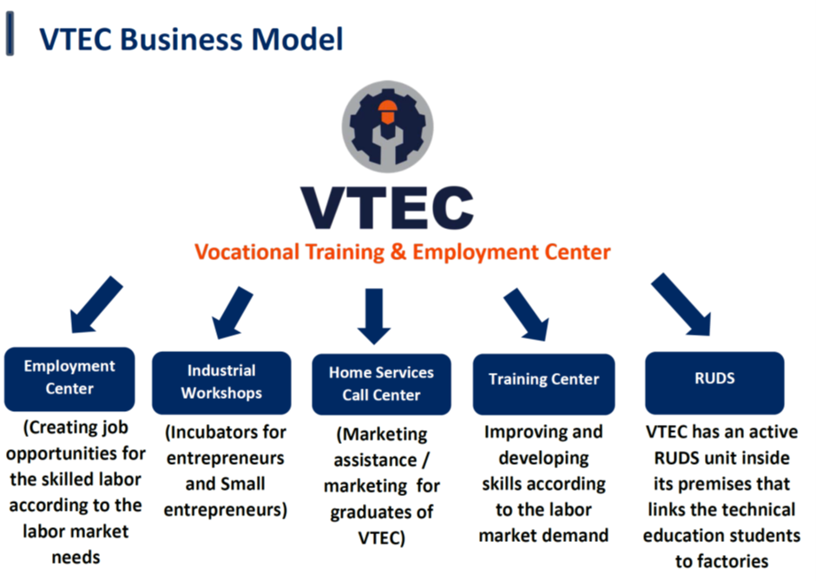
The main objective is to get disadvantaged job-seekers into an apprenticeship training programme aimed at
- meeting the labour market’s need for skilled workers; and
- promoting skills development and personal development of the job-seekers.
At the end of the apprenticeship training, some apprentices will be offered permanent formal employment.
The duration of the apprenticeship programme is about six months, of which 3 months are implemented at the VTEC and 3 months at the workplace. The three months at the workplace are under the full responsibility of the companies but incorporate accompanying activities undertaken by VTEC, e.g. visits and casual consultations with the apprentices.

The Tool: Career Advisory and Consultancy Service Tool
The tool identified is mainly applied during the design phase of the apprenticeship. The tool, a career guidance process, more specifically a career advisory and consultancy service, is used to guide the job-seekers to the relevant field of occupation, meeting their aspirations and capacities.
The main purpose of the tool is (i) to select candidates having the prospect of and interest in meeting the employment requirements mentioned in the job vacancies of companies, (ii) to design specific training activities, (iii) to advise the candidates on the right training and employment, and (iv) to support the apprentices during the apprenticeship programme.
The training alternates between workshop training at the VTEC and workplace-based training in the companies in vocations such as carpentry, automotive mechanics, tailoring, refrigeration and air conditioning maintenance and electrical installation.
Based on the career guidance process, the VTEC designs the apprenticeship training that meets the needs of the job-seekers. If the VTEC staff notice challenges during the skills development process, they will set up a specific training facility to address the challenges. Similarly, during the in-company training stage, a career guidance tool is also applied as illustrated in the figure below.
The justification of the initiative is based on its specific features of meeting the needs of both sides, the companies and the job-seekers. From the perspective of companies, the apprenticeship programme aims to close job openings through apprenticeship training. From the perspective of the job seekers, the activities of VTEC are aimed at closing the skills gap and strengthening the work attitude of the candidate by means of tailored training. It should be noted that the driver of the apprenticeship programme is the VTEC and not the companies. However, once the programme has proven successful, companies might be increasingly active also during the initial stages.
Figure 2: Apprenticeship Programme Process, Part 1 and 2
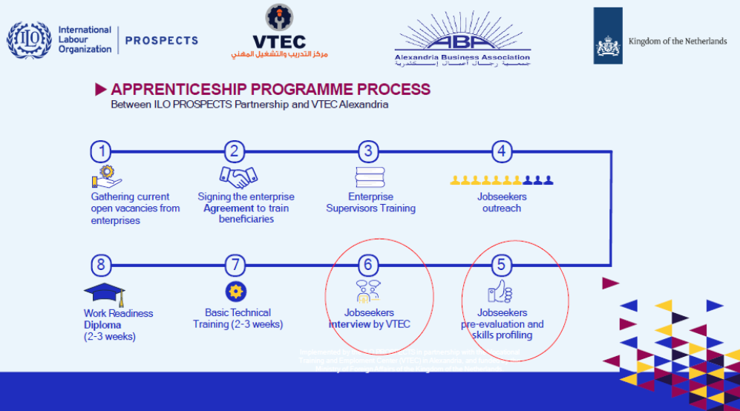

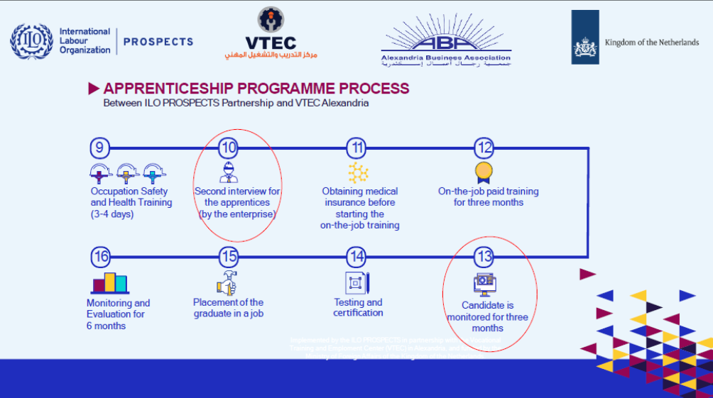
Source: Presentation of ABA-VTEC Apprenticeship
The red cycles in the figure above depict the points where the career advisory and consultancy service tool is used within the framework of the apprenticeship programme process. It enables both sides, companies with their need for qualified labour and job-seekers with their employment needs and specific aspirations, to match.
At position 5 of the Apprenticeship Programme Process (see figure above), the first activity happens within the tool career guidance process to do a job-seekers pre-evaluation and the matching with the skills profiles of the involved companies. It is a standardised activity based on job profiles. One source of the job profiles is the centre’s own competence library, the ISCO job profiles and other public sources.
The other source is the job profiles established by the companies. The skills profile definition is an important activity and a precondition for a successful apprenticeship programme. Experience shows that most companies do not have any elaborated and standardised skill profiles. Very often companies are using informal or experienced-based job descriptions. It is only larger companies that have a human resource department that is capable of developing contemporary job descriptions.
The VTEC has longstanding relevant experiences and uses different means to define job profiles. The centre has fourteen occupations established as standard profiles consisting of basic skills, working skills and soft skills. Based on these experiences the VTEC has developed a checklist to facilitate obtaining information relevant for a job description of a specific position at the companies.
Additionally, the staff of VTEC communicate with the employers about necessary on-the-job skills to find out what and how the training can be provided. As a result of the communication with the employer, a common understanding of competencies is established. Jointly, this will provide relevant information for the pre-evaluation of jobseekers to establish the link between one or more job-seekers and the vacant position at the company.
After the competencies profiling, the next step is at position 6 where the career guidance officer of the VTEC conducts the first interviews with the job-seekers. During the interview, the VTEC recruitment specialist seeks to identify the expectations and aspirations of the job-seekers and advises them on the relevant occupation and training. The recruitment specialist is also providing orientation towards the needed attitudes and work behaviour as a means to define specific training needs of the job-seeker. If someone ‘fails’ during the interview with regard to his/her appropriateness for a specific position, he/she will be offered additional chances to find a better match. The two steps will lead to specific training on basic skills, optional skills and soft skills depending on the occupation/competencies needed.
Once the training at the VTEC has been successfully completed, the final job interview (position 10) is conducted. The company conducts the interview which is aimed at verifying that the trainee is the right person for the company and that he/she actually gain the needed competencies during the training at the VTEC. The VTEC prepares the candidates for that interview, organises the transportation and will get feedback from the companies. Following a successful interview, the apprentices become part of the labour market under the companies’ responsibility no longer directly under the VTEC supervision and responsibility. During the in-company training period (apprenticeship period), staff members of the VTEC are supporting and monitoring the apprentice (position 13) once a month. The meeting is aimed at discussing the progress made, inter alia by reviewing the apprentices’ logbook which is to reflect the learning and serves as documentation for paying the apprentices the monthly remuneration.
The role of the VTEC is partly that of a ‘mediator’ serving both the needs of the companies and the job- seeker/apprentice. Some of the job-seekers/apprentices are from disadvantaged slum areas and attention is also given to the participation of young women. Among the job seekers/apprentices and graduates there are also refugees from Syria, Sudan and Yemen. Jointly, they represent youth that, in general, find it difficult to enter skills training, let alone enter the labour market.
As illustrated above, the VTEC is also offering support to companies on their training needs through defining skills training based on a common understanding of occupations/competencies needed, the setting of standards for job profiling and providing guidance to candidates and companies in terms of skills development and apprenticeship training. This represents a kind of advisory service which companies will appreciate with regard to further strengthening the cooperation between VTEC and companies.

On 7th August 2021, 42 trainees from an apprenticeship programme graduated

Source: Refugee and host community apprentices graduate in Alexandria, Egypt
https://www.ilo.org/global/programmes-and-projects/prospects/news/WCMS_822659/lang--en/index.htm
Pros and Cons of the tool
Pros
- Focusing on the characteristics of the job-seekers/apprentices, the Career Advisory and Consultancy Service tool will address the needs of both the job-seekers and companies meeting challenges in the hiring process, e.g. companies are not 100% clear about which skills and competencies they need, low self-esteem of job-seekers, low recognition of own personal values, limited understanding of work ethics and others.
- In recent years, addressing the needs of refugees has become a challenge in many African countries. To help these refugees successfully integrate into their new communities, many countries have provided vocational training programmes to help them find employment and become self-sufficient. TVET programmes for refugees typically focus on areas such as language and cultural knowledge, job search skills, computer skills, and technical skills. Language and cultural knowledge classes help refugees learn the language of their new country and understand the social customs and etiquette of their new home. Job search skills classes teach refugees how to write resumes, complete job applications, and interact with potential employers. Computer skills classes help them become comfortable with computer technology and use it to their advantage in their job search. Technical skills classes provide hands-on instruction in areas such as carpentry, plumbing, electrical work, and other trades that can help refugees find jobs in those fields.
The present tools and the programme in which it is embedded are specifically targeted at disadvantaged groups, including refugees and women. The tool/programme is particularly valuable for refugees for whom it is otherwise very hard to get access to vocational training and employment.
It is noticeable that refugees are trained alongside local youths thereby offering equal support to refugees and local youths, which means that the programme/tools are not seen as favouring refugees over local disadvantaged youths - an approach that is likely to facilitate the integration of the refugees, thus increasing the cultural acceptance of their entering the labour market and employment.
- The tool will identify the competencies needed by the company and the training needs of the job- seeker as well as facilitate the apprentices' transition from the status of a VTEC learner to that of an apprentice at the company, which may lead to permanent employment.
- An advantage is the close contact with the companies and the establishment of a communication and cooperation structure that may lead to a mutual understanding of how to meet skills needs best and how to facilitate youths’ entry to the labour market. Additionally, the VTEC gets insights into the skills needs of the businesses and could also establish a common language and understanding of occupation and job profiles. These joint efforts may ease future cooperation with the companies in various fields, such as recruitment, apprenticeship or further training of companies’ staff.
- The implementation of a structured process will help companies and job-seekers assess where they are in the process and what it takes to progress. The tool implies the provision of advice and regular feedback to the candidates (before the apprenticeship programme start) and the participants/trainees (during the apprenticeship programme) with regard to their progress. Also, this approach will be of special importance for refugees as it may help build trust and an understanding among refugees of the local social/cultural preconditions for entering the labour market and overcoming existing constrains.

Cons
- The main constraint is most likely the fact that the above-mentioned structured process is complex and therefore also resource-demanding. These will be aspects to consider when establishing a similar system. However, if the result is high employment rates it will be worth the cost.
- There is a clear need for commitment on both sides – companies and job-seekers alike. The contractual basis of the whole apprenticeship initiative is between VTEC and each company. There is actually no possibility of holding companies accountable for not fulfilling the agreement, which may be seen as a potential challenge. The same applies to the job-seekers. There is no legal basis, e.g. an apprenticeship contract. This may take the apprenticeship responsibility away from the main parties, i.e. the company and the job-seeker. Experience seems to suggest that companies are not ready to sign an apprenticeship contract with the apprentice.
- The lack of an adequate legal framework for apprenticeship affects also the social security and medical insurance of the apprentices. An apprenticeship contract would include provisions on social security and medical insurance for the apprentices. In the absence of an apprenticeship contract, such important issues are not sufficiently covered.
- Funding is another related challenge. As the apprenticeship programme is free of charge for both companies and job seekers, it may negatively affect the commitment of both sides. Acknowledging the problem, the VTEC has addressed the issue with the relevant authorities for further deliberations.
- Vocational training is an important part of helping refugees find decent employment and assimilate into their new communities. However, offering vocational training to refugees can present a number of challenges that should be considered before offering skills training to refugees.
First, there is a language barrier. When refugees arrive in a new country, they may not have the language skills necessary to understand and participate in the training process. This may lead to a lack of communication and difficulties in understanding instructions, which, in turn, may lead to frustration and a lack of progress.
Second, there is a lack of access to resources. Refugees often have limited financial resources and a limited supporting network in the host community, making it difficult for them to attend classes and/or pay for the materials they need to learn the skills required or to gainfully engage in self-employment.
Third, there is a lack of cultural understanding. Refugees may come from very different backgrounds and cultures than those in their new host community. Without an understanding of the culture and customs of their new home, they may find it difficult to participate in training sessions and understand the expectations. The cultural background can also determine which vocations are acceptable for men and women, which might be different from the host community.
Fourth, there is a lack of trust. Refugees may not trust those in charge of their training, and may be hesitant to take part in activities that might put them in danger. This may lead to a lack of engagement and a lack of progress in the training.
Finally, there is a lack of support. Without proper support and guidance, refugees may find it difficult to take part in the training and make progress. This can be especially true for those with limited education and few job prospects.
Testimonials
The Vice-Chairman of the ABA, Eng. Hesham Aboul Ela is satisfied with the achievements: "The role of VTEC is centred on empowering young women and men job-seekers and linking them to business sectors." - "The apprenticeship programme provides people with the opportunity to learn and work in different sectors and to ensure that training is well adapted to work requirements." - "Through this educational journey, the programme supported the training of participants on basic techniques; and by the end of these courses, jobseekers will acquire skills and experience within the workplace that will help them access more and better jobs."
The achievement has gained national attention as a statement of the ILO Egypt representative Mr Oechslin shows: “Through the PROSPECTS Partnership, the ILO in Cairo aims to increase the access of refugees and Egyptians to decent work opportunities in the labour market, notably through the apprenticeship programme established in partnership with the VTEC. Job-seekers undergo an entire process that meets their needs and enhances their experience and skills. The provision of skills development methodologies and tools contributes to reducing unemployment rates within Egyptian and refugee communities and increases job-seekers access to decent work opportunities. It can also lead to the development and strengthening of Egyptian enterprises as a result of the training and development that job-seekers undergo."
“The role of VTEC is centred on empowering young women and men job-seekers and linking them to business sectors,” said Eng. Abou Ela. “The apprenticeship programme provides people with the opportunity to learn and work in different sectors and to ensure that training is well adapted to work requirements.” “Through this educational journey, the programme supported the training of participants on basic techniques; and by the end of these courses, job-seekers will acquire skills and experience within the workplace that will help them access more and better jobs,” said Mr Obeid.

Source:
- Alexandria Business Association https://www.aba-vtec.com/en
- Alexandria Business Association. https://id.icomtoolbox.org/site/aba/business-units-vtec/
- El-Ashmawi, A. (2019). Enhancing institutionalized partnerships between TVET institutions and the world of work in Egypt. https://en.unesco.org/sites/default/files/enhancing_institutionalized_partnerships_between_tvet_institutions_and_the_world_of_work_in_the_arab_region_unesco_2020c.pdf
- PROSPECT programme visit this page https://ilo.org/wcmsp5/groups/public/---dgreports/---ddg_p/documents/publication/wcms_808971.pdf
- Refugee and host community apprentices graduate in Alexandria, Egypt, https://www.ilo.org/global/programmes-and-projects/prospects/news/WCMS_822659/lang--en/index.htm
- Video: https://youtu.be/kx5g7Usu3WA
- VTEC Profile 2020, internal PowerPoint presentation

Through this paper, the African Union abbreviation – Egypt – will be used.
Disclaimer: This publication was produced with the financial support of the European Union and the German Federal Ministry for Economic Cooperation and Development. The views and opinions expressed herein are those of the authors or persons cited and do not necessarily reflect the official policy, view or position of AUDA-NEPAD, the European Union or the German Federal Ministry for Economic Cooperation and Development. The terms used herein and the presentation of material therein do not imply any endorsement by AUDA-NPAD, the European Union or the German Federal Ministry for Economic Cooperation and Development. Information in this book is offered in the understanding that it does not contain legal, financial or other forms of professional advice. Although the author has made great efforts to ensure the accuracy of the content, errors and omissions may occur.
For more information on the PROSPECT programme visit this page https://ilo.org/wcmsp5/groups/public/---dgreports/---ddg_p/documents/publication/wcms_808971.pdf
Acknowledgement and thanks go to the operations manager of the VTEC, Ahmed Ebrahim for providing valuable information for this presentation.

