**Mapping practical tools that facilitate the implementation of formal apprenticeship in the**

**Republic of** **Malawi[1]**

**‘Apprentice Selection Process Tools’[2]**

|  |  |
| --- | --- |
| **Tool** | Apprentice Selection Process Tools |
| **Tool focus** | For a formal nation-wide dual apprenticeship programme, this tool describes an annual apprenticeship selection process and the tools used to this end. |
| **Target group** | Public TVET authorities/institutions that undertake the selection of students/trainees/apprentices regularly. |

**The Programme: Malawi - Formal Apprenticeship Programmes**

In Malawi, the Technical, Entrepreneurial and Vocational Education and Training Authority (TEVETA) is the regulatory body of Technical, Entrepreneurial and Vocational Education and Training (TEVET). Established in 1999 by an Act of Parliament with the mandate to regulate, promote and facilitate the sustainable provision of quality TEVET in Malawi.

Formal apprenticeship is one of the TEVET programmes regulated and facilitated by the TEVETA. The programmes are implemented as three/four-year dual-apprenticeship programmes with competency-based training modules delivered by registered TEVET providers, such as national and community technical colleges, rural-based Community Skills Development Centre and selected employers.

**Access**

Formal apprenticeship is accessible for those holding a Malawi School Certificate of Education (MSCE) and/or its equivalent. Credit passes in English, Mathematics and a Science subject is an added advantage. A recruitment process follows an advertisement, application, shortlisting, and ultimate selection of successful candidates into registered Training Centres.

**Available Apprenticeship Programmes**

Administrative studies Automobile Mechanics Bricklaying Carpentry and Joinery Cosmetology Fabrication and Welding

Electrical Installation and Electronics Food Production

General Fitting Edible Horticulture

Information and Communication Technology Motor Cycle Mechanics

Painting and Decoration Plumbing

Refrigeration and Air Conditioning Mechanics Solar Photovoltaic

Tailoring and Fashion Design Tour Guide

Vehicle Body Repairing and Refinishing Wood Work Machining

Source: 2022 Training Opportunities TEVETA.

Females and persons with disabilities are strongly encouraged to apply.

Selected candidates are notified through newspapers and electronic media. Trainees under this programme are called ‘apprentices’.

**Apprenticeship Programme Structure**

The three-year apprenticeship training programmes are implemented at registered training centres (TC) as classroom and workshop training and at selected employers as work-based training – industrial attachment[3]. As demonstrated in the below three-year training plan, each academic year is broken down into three terms, each around 12 weeks with standardised breaks around April, August/September and December. Furthermore, the apprenticeship programmes are organised as one year of initial full-time training at a TC, with the second and third year being split into two terms of enterprise-based training and one term of TC instruction.

This means that in year one apprentices spend January, February and March at a TC, while in year 2 and 3 apprentices spend this time on industrial attachment. After a short holiday in April, year 1 apprentices return to the TC, while year 2 and 3 apprentices return to industrial attachment until the end of July. The holiday break lasts from the beginning of August into the first week of September for all apprentices. After this, all trainees return to the TC before starting the exams in November.

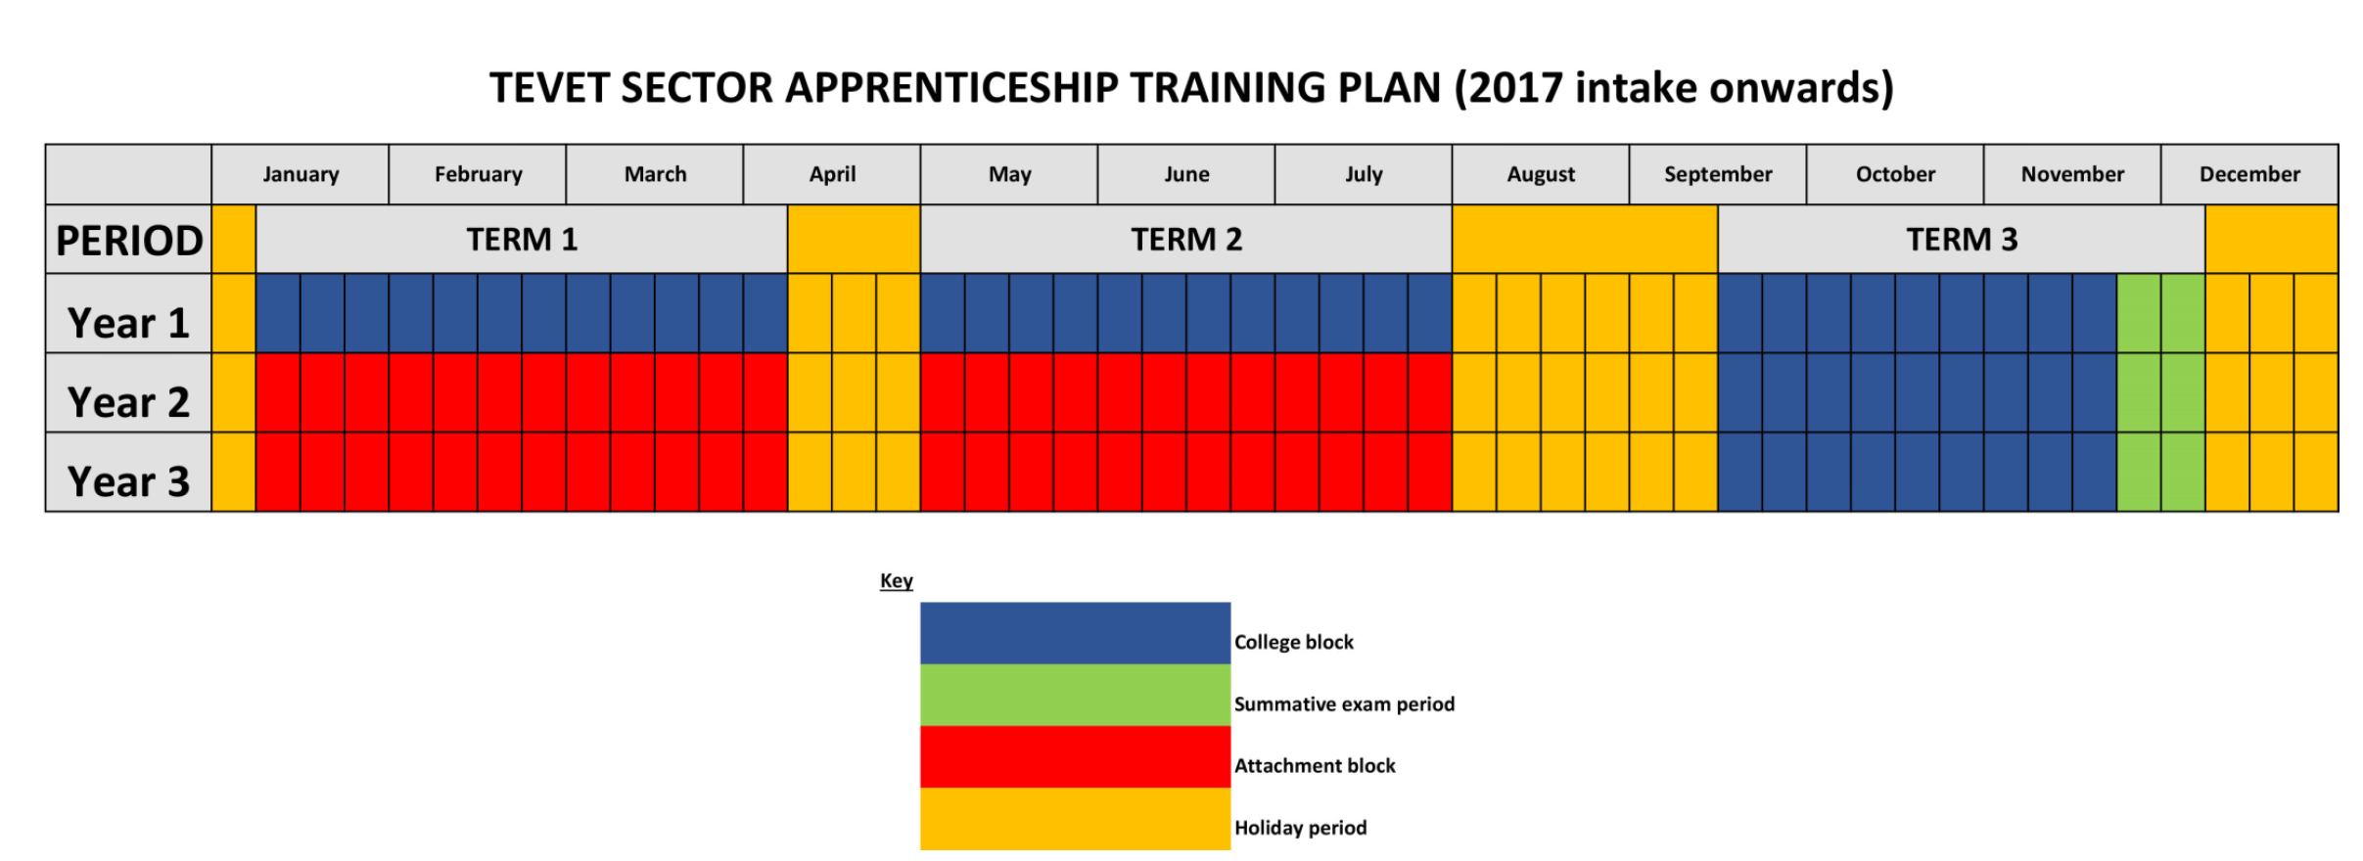

Source: TVET Trainee Orientation Manual. TEVET Authority. <https://www.stepmalawi.com/wp-content/uploads/2019/06/TEVET_Trainee-Orientation-Manual.pdf>

**Assessment and examination**

The apprentices are assessed both at TC and during the industrial attachment. At TC there are two types of assessments:

1. Continuous Assessments, which are further broken down into:
   1. Formal theoretical and practical assessments at the end of a module (conducted by each college and internally verified)
   2. In-class assessments that are externally verified
2. Summative assessments (at the end of each year, done as a national exam by the Assessment and Certification Unit).

During the industrial attachment, the ‘Apprenticeship Training Logbook’ will be used for assessing learning progress. The apprentice is given an ‘Apprenticeship Training Logbook’ at the beginning of the apprenticeship programme. The Logbook belongs to the apprentice and outlines all the different competencies that the apprentice is expected to master after completion of various modules. It is the tool for ongoing assessments by supervisors at the TCs and during the industrial attachment.

The summative assessments are both theoretical and practical. The below table shows the different content and duration depending on the level and type of assessment.

|  |  |  |
| --- | --- | --- |
| **Level** | **Type of questions** | **Length** |
| 1 | Multiple choice and short answer questions | 1 hour and 30 minutes |
| 2 | Multiple choice, short answer questions and structured questions | 2 hours |
| 3 | Structured essay questions | 3 hours |
| 4 | Structured essay questions | 3 hours |

Source: TVET Trainee Orientation Manual. TEVET Authority. <https://www.stepmalawi.com/wp-content/uploads/2019/06/TEVET_Trainee-Orientation-Manual.pdf>

Practical tests are developed by assessors from the ‘Assessment and Certification Unit’ and vary from vocation to vocation and from level to level as shown below.

The industrial supervisor in the enterprise will register the apprentice’s daily attendance along with the daily assignments in the Logbook that will stay at the workplace during the industrial attachment.

The supervisor manages the assessments and oversees the keeping and updating of the logbook. TEVETA officers monitor the apprentice’s progress before an external verifier will verify his/her achievements.

There are four grading levels: Distinction, Credit, Pass, and Fail. These grades are given according to the results achieved by the apprentice during the assessment.

Successful graduates will be awarded certification at four levels: Assistant operatives (Level 1), operatives (Level 2), artisans (Level 3) and technicians (Level 4).

|  |  |  |  |  |
| --- | --- | --- | --- | --- |
| **Year/Level** | **Vocation type** | **Credit requirements** | **Course content** | **Qualification title** |
| 1 | Assistant Operative | 120 | Foundational modules | TEVET Foundation Certificate |
| 2 | Operative | 240 | Intermediate level modules | TEVET Intermediate Certificate |
| 3 | Artisan | 360 | Advance level modules | TEVET Advanced Certificate |
| 4 | Technician | 480 | Diploma level modules, incl. managerial and supervisory skills | TEVET Diploma |

Source: TVET Trainee Orientation Manual. TEVET Authority. <https://www.stepmalawi.com/wp-content/uploads/2019/06/TEVET_Trainee-Orientation-Manual.pdf>

The apprenticeship programme is financed on a cost-sharing basis. The apprentices pay pre-set tuition and examination fees directly to the training providers, while TEVETA pays a subsidy for the cost of training at the TEVET providers.

**The Tool: Apprentice Selection Process Tools**

Each year TEVETA initiates a formal and well-structured process for the selection of apprentices. It is a process that has been practised since 2019 and is managed by a Recruitment Committee composed of members from TCs across Malawi. The different stages of the process are facilitated by TEVETA, providing technical support while the Ministry of Labour is overseeing of the process.



The recruitment process starts off with the establishment of a ‘Pre-Apprentice Recruitment Calendar’. The calendar becomes a practical tool used during the sub-stages in the selection of apprentices. As shown below, the tool is quite detailed and provides a timeframe for each activity linked to an ‘actor’ that is responsible for implementing the activity.

**Figure 1: Pre-Apprentice Recruitment Calendar for 2021**

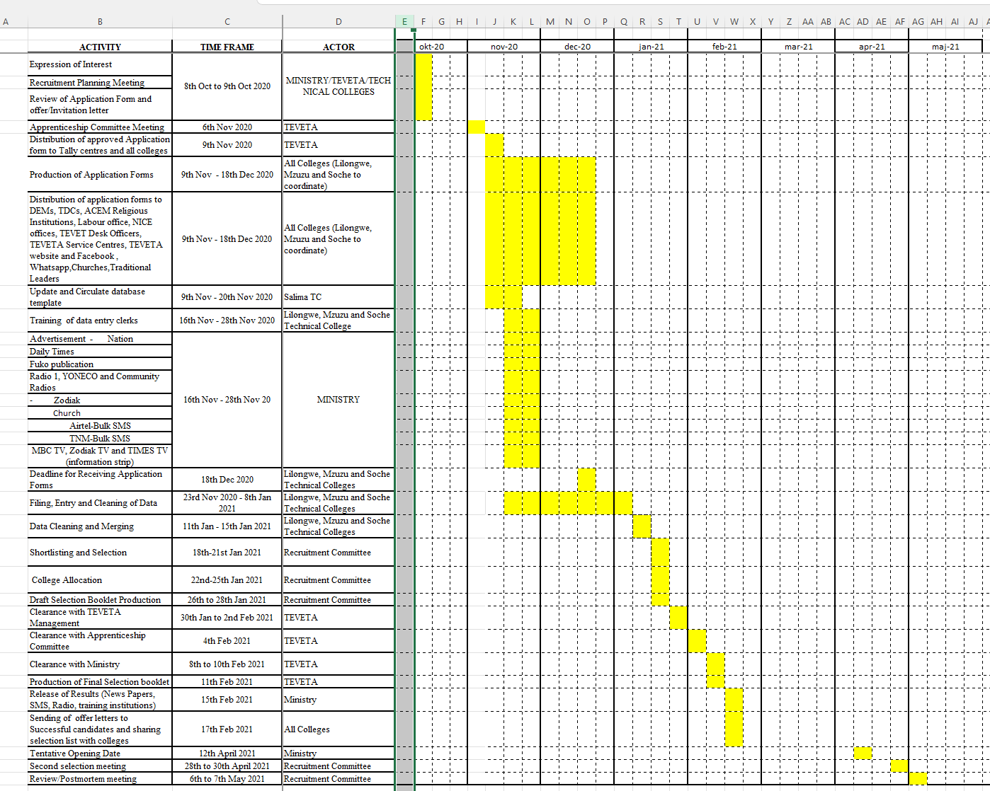

Source: 2021 National Selection List - Pre-Apprenticeship Recruitment Results. Tuesday 30th March 2021. TEVET Authority. <https://tevetamw.com/download/2021-pre-apprenticeship-recruitment-results/>

Going through the activities it is clear that the Pre-Apprentice Recruitment activities move towards the actual selection followed by the announcement of the selection, and ending with a review meeting.



Simultaneously, and through a consultative planning stakeholder meeting, the number of apprentices to be selected and the vocations to be offered is established based on the TCs' capacity and demands. The balancing of capacity and demands will also be the basis for resource allocation. This will be of great importance for the implementation of the various apprenticeship programs and, of course, for the individual apprentices.



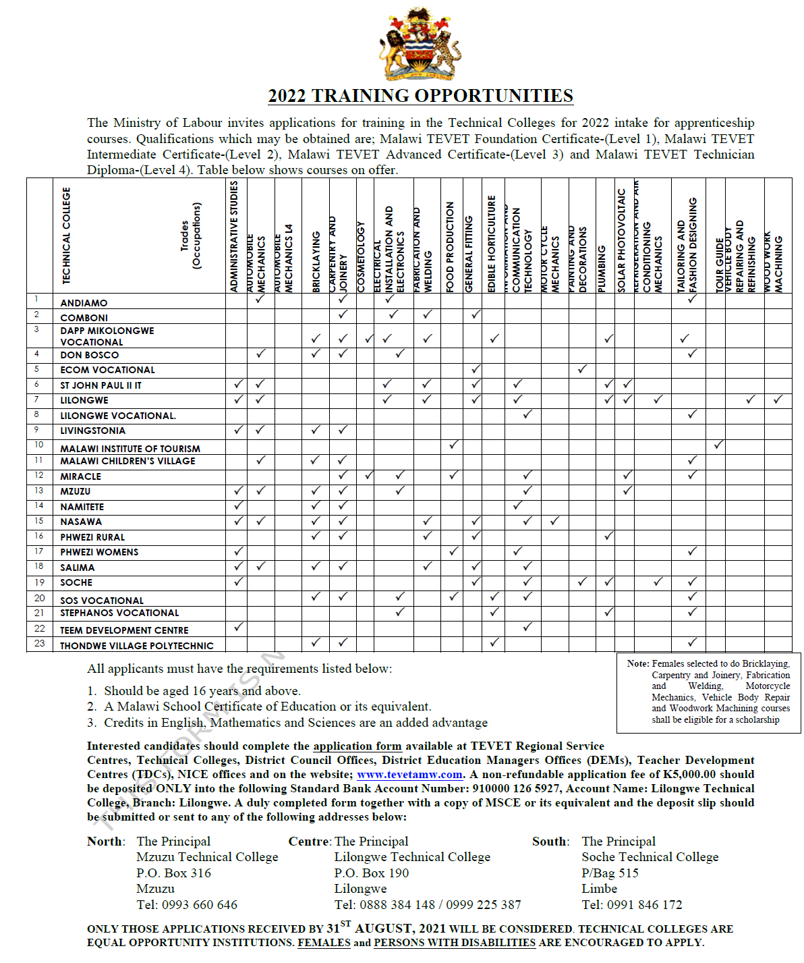Subsequently, the MoL will issue a general advert for the recruitment of apprentices along with a list of the apprenticeship programmes offered at the registered TC. The 2022 MoL apprenticeship advertisement (see figure) shows which apprenticeship programmes are offered at which TC provider. The application requirements, where to obtain the application form, the application fee, documents to accompany the application, where to hand in the application and the related deadline are all mentioned in the advertisement.

It is noteworthy that a scholarship is available for females selected for several usually ‘male-dominated’ vocations.

The advertisement is published in newspapers, on radio programmes, on social media as well as in other relevant places such as the TCs.

The application form is the very tool used to identify potential apprentices and screen applicants. To ensure accessibility, application forms are produced and distributed to all districts by the TCs in the country. Application forms are also made available to District/Town Councils (through TEVETA Desk Officers), District Education and Labour Offices, National Initiative for Civic Education offices and Teacher Development Centres, where Primary Education Advisors collect them for further distribution in their areas. The forms can be downloaded from the TEVET and TCs websites and were also shared through social media.



Besides providing basic information, the applicants can name three priorities but also if they would be interested in non-residential apprenticeship possibility and/or be trained at any TC they might be selected for. These are very important considerations as they will likely have financial implications for the apprentices’ families in terms of transport and cost of living. What might be equally important is the prospect that an apprentice might have to find alternative lodging, other than at a TC dormitory. A prospect that might be a barrier especially for female applicants.

Applications and data entered into the database are subject to quality checks during the merging and cleaning stages. Applications lacking the requested attachments (e.g. MSCE, proof of payment, passport photo, incompletely filled in etc.) are rejected, thus ensuring that only applicants entered into the database are eligible for selection. The processed application data from the three TCs (Soche, Lilongwe and Mzuzu Technical Colleges) are fed into a national database. The processed data is then submitted to the national selection committee composed of representatives of the MoL, TEVETA and both public and private TCs. At the central level, any overlaps, duplicates and inconsistencies in the databases are addressed.

For the 2022 selection process the below criteria were applied:[4]

1. Possession of a Malawi School Certificate of Education (MSCE);
2. Pre-requisite subject combination at MSCE for particular programmes (e.g. for Electrical Installation and Electronics, Science subjects are required);
3. In the event of a tie, consideration was made based on an applicant’s Malawi School Certificate of Education subject scores;
4. Affirmative action was considered for applicants with disabilities;
5. Gender balance of 50:50 in all male-dominated trades;
6. Gender balance of 40:60, males to females for the female-dominated trades;
7. Allocations to colleges were based on the choice of the applicant wherever it was possible; and,
8. A merit-based selection system of recruitment is used.

In 2021 TEVETA began piloting an online recruitment portal making it possible for candidates to apply from anywhere in the country as long as they have access to the internet.



A so-called ‘Apprenticeship Selection Booklet’ is produced describing the entire selection process and having all the names of the selected apprentices. The booklet - the structure of which has been more or less the same over the years - is submitted to the Apprenticeship Committee first and thereafter to the MoL for final approval. Following the approval, the results were made available to the general public.

In addition, the booklet includes a comprehensive presentation of the application and selection data presented soundly with supporting diagrams, which makes it ‘fit for purpose’. An example of that is the figure below showing TCs’ intake capacity, the number of applications and selection by vocation - information that can be used for TEVET planning.

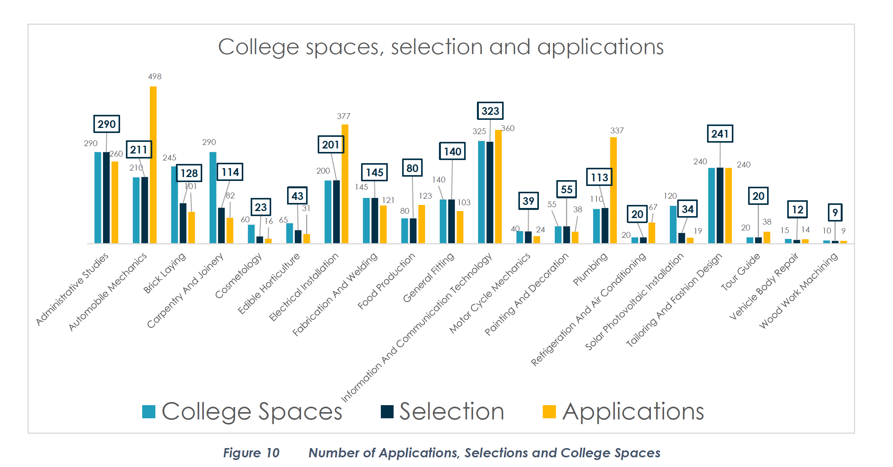

Source: 2022 National Selection List - Pre-Apprenticeship Recruitment Results. Friday 24th September 2021. TEVET Authority. <https://tevetamw.com/download/2022-apprenticeship-selection-booklet/>

As a final note, it should be mentioned that the cost of the above-presented apprentice’s selection process is covered by the application fees.

**Pros and Cons of the tool**

**Pros**

* The selection of trainees is an important process - not only because it will determine who is selected to join a TVET but also because it should establish why others were not selected. To be credible a selection process should apply clear and as much as possible unambiguous criteria that are applied inevitably. In this way unsuccessful applicants may have a better chance to understand how they can prepare and improve to meet the selection criteria should they wish to apply again.
* Establishing a selection process with clear steps, activities, deadlines and responsibilities will go a long way to meet these requirements. The pre-recruitment calendar is an example of such a tool – not complicated and easy to use.
* Transparency is another important element that helps build credibility and trust in the selection. Candidates need to understand the process and the requirements for selection to be able to receive guidance and make a fair application. TEVETA’s selection announcement provides information on the registered TC and the vocational apprenticeship programmes they offer. Also the report on ‘National Selection List - Pre-Apprenticeship Recruitment Results’ provides information and insight into the selection process thereby facilitating transparency.
* In many cases, the number of applications will exceed the number of apprenticeship places. Therefore, a situation can very often arise where two or more applicants meet the admission requirements but where a selection has to be made. It is therefore relevant to have procedures in place to handle such situations.
* It is also common that not all the selected apprentices report to the TC they have been selected for. Experience will help indicate how many will not report, thus making it possible to select an appropriate number. In the case of the 2021 selection in Malawi, the selection report mentioned that experience over recent years had shown that an average of 40% of the selected apprentices did not report. To avoid an expensive second round of selection, of which 30% did not report, the selection committee decided to recruit an extra 40% to avoid any gaps.

**Cons**

* It is important to observe that a selection process will require a certain managerial capacity by the responsible institution. No matter how clear and transparent the selection process is, it is very likely that the responsible institution will receive several applications that clearly do not meet the entry requirements.
* Because any apprenticeship programme relies heavily on employers’ engagement, their active participation should be facilitated. Employers’ associations and/or individual employers might find time to participate and it could be one way of strengthening the TC – employer cooperation which could benefit the industrial attachment process.
* Whenever an orientation manual refers to specific forms or contracts, it will be relevant to mention where they can be obtained and/or where they can be downloaded. The apprenticeship contract that covers a significant portion of the programme will have apprentice interest. Providing a sample contract could help understand the contractual aspects of the apprenticeship programme.

**Source:**

2021 National Selection List - Pre-Apprenticeship Recruitment Results. Tuesday 30th March 2021. TEVET Authority. <https://tevetamw.com/download/2021-pre-apprenticeship-recruitment-results/>

2022 National Selection List - Pre-Apprenticeship Recruitment Results. Friday 24th September 2021. TEVET Authority. <https://tevetamw.com/download/2022-apprenticeship-selection-booklet/>

Strategic Plan 2018-2023 TEVET Authority. <https://tevetamw.com/downloads/?cp=4>

Technical And Vocational Career Choices in Malawi. Ministry of Labour and Manpower Development. November 2014. TEVET Authority.

Technical, Entrepreneurial and Vocational Education And Training (TEVET) Policy. Ministry of Labour. 2013. <https://tevetamw.com/downloads/?cp=4>

Technical, Entrepreneurial and Vocational Education and Training Act, 1999. <https://tevetamw.com/downloads/?cp=4>

TVET Policy Review – Malawi. 2010 UNESCO. <https://unesdoc.unesco.org/ark:/48223/pf0000190216>

TVET Times Vol. 21 April – June 2021. <https://tevetamw.com/download/tevet-newsletter-april-june2021/?wpdmdl=9206&refresh=625437eda13c41649686509>

TVET Trainee Orientation Manual. TEVET Authority. <https://www.stepmalawi.com/wp-content/uploads/2019/06/TEVET_Trainee-Orientation-Manual.pdf>

1. Through this paper, the African Union abbreviation – Malawi – will be used.
2. Disclaimer: This publication was produced with the financial support of the European Union and the German Federal Ministry for Economic Cooperation and Development. The views and opinions expressed herein are those of the authors or persons cited and do not necessarily reflect the official policy, view or position of AUDA-NEPAD, the European Union or the German Federal Ministry for Economic Cooperation and Development. The terms used herein and the presentation of material therein do not imply any endorsement by AUDA-NPAD, the European Union or the German Federal Ministry for Economic Cooperation and Development. Information in this book is offered in the understanding that it does not contain legal, financial or other forms of professional advice. Although the author has made great efforts to ensure the accuracy of the content, errors and omissions may occur.
3. Industrial attachments usually refer to the formal placement of trainees in the workplace to facilitate the achievement of specific learning outcomes that would potentially lead to their employability on completion of a training programme. Industrial attachments typically involve training providers and industries (through employers) forming partnerships to offer situated learning opportunities in the workplace so that learners and technical and vocational education and training (TVET) practitioners have access to authentic experiences that only the workplace can offer.
4. The selection criteria may be refined over time.