‘The Dual Apprenticeship Training System (DATS), in the Republic of Tanzania

Initiative | An apprenticeship initiative introducing dual system models to Tanzania. Developed and delivered in collaboration between a development partner, Hamburg Chamber of Crafts (HWK), the national VET agency, Vocational Education and Training Authority (VETA), and employers.
Initiative focus | This initiative is aimed at introducing dual system programmes in key sectors to Tanzania through the implementation of a ‘block release’ system that embeds both centre and work-based learning elements
Target group | Employers planning to hire apprentices, prospective apprentices/trainees, TVET providers (VETA centres) partnering employers in the delivery of apprenticeships, industry mentors, and VETA officials

Introduction
Tanzania’s TVET strategy is driven by the country’s ‘Vision 2025’ which sets out the objective to grow TVET quality, relevance and access to TVET through the development of employer demand-oriented TVET programmes, enhanced training facilities and effective financing models. Alongside the development of technical skills, TVET is viewed as a medium for developing citizenship and the expansion of life skills needed to meet changing economic and social needs. Tanzania’s TVET strategy has been developed through a series of sector interventions:

Medium term strategic plan (2012/13 – 16), prioritising:
- Increased access to TVET,
- Increased skills for self-employment,
- Increased links with industry,

The National Strategy for Growth and Reduction of Poverty II 2010-2015, prioritising:
- Increase in number and relevance of apprenticeships through stronger employer engagement,
- Increased enrolment and empowerment of women and disadvantaged groups,
- Curriculum updated to be relevant to labour market.

A more recent initiative has been the National Skills Development Strategy 2016 -21 (NSDS), funded through the Skills Development Fund (funded through the Skills Development Levy), which has the objective of ensuring the development of a skilled workforce in six priority economic sectors through more effective engagement between TVET and the Private sector. These sectors are:
- Agriculture, Agribusiness and Agro-Processing,
- Tourism and Hospitality,
- Transport and Logistics,
- Construction,
- Information and Communications Technology,
- Energy.
One of the key themes that runs through Tanzania’s TVET sector interventions has been the acknowledgement of the importance of closer alignment and engagement between training and the private sector, including through the introduction of enhanced work-based learning models and practices. The realisation of this priority is central to the ‘Dual Apprenticeship Training Scheme (DATS) initiative presented in this report.
TVET in Tanzania
The Tanzanian TVET sector is governed by the Ministry of Education, Science and Technology (MoEST) through the division of Technical Vocational Education and Training Development. The division manages Tanzania’s two key VET agencies, the National Council for Technical and Vocational Education and Training (NACTVET) and Vocational Education and Training Authority (VETA). NACTVET is mandated to lead on:
- Regulation through the establishment and implementation of TVET regulatory frameworks, that lead to quality assured qualifications,
- Quality Assurance to ensure the quality of TVET provision and the relevance of programmes for labour market demand,
- Advice to both Government and technical institutions on TVET strategic development.

VETA is mandated to lead on:
- Provision of vocation education and training (VET) through a national network of 33 VETA training centres and a national VET instructor training college (Morogoro),
- Coordinating VET through other providers delivering long, short and tailor-made courses,
- Conducting LMI surveys to identify skills demands and training needs in key sectors,
- Centre registration and accreditation,
- Curriculum and assessment development,
- Managing the national Skills Development Fund resourced through the Skills Development Levy,
- Championing and promoting the TVET sector.
TVET in Tanzania is delivered through two sub-systems, vocational education and training (VET) and technical education and training (TET).
TVET programmes are offered at the secondary education level; at the Ordinary Level students can opt for two-year programmes in vocational and crafts training avaliable at public district and regional vocational and technical training institutes and registered private TVET institutions. A lack of formal pathways means that students who take vocational and crafts training will not be able to proceed to the next level of education and will normally enter the labour market. Advanced Level students can opt for three-year technician training courses. TVET at the tertiary education level is offered in universities, university colleges, and tertiary-based institutions.

TVET formal, non-formal and informal systems
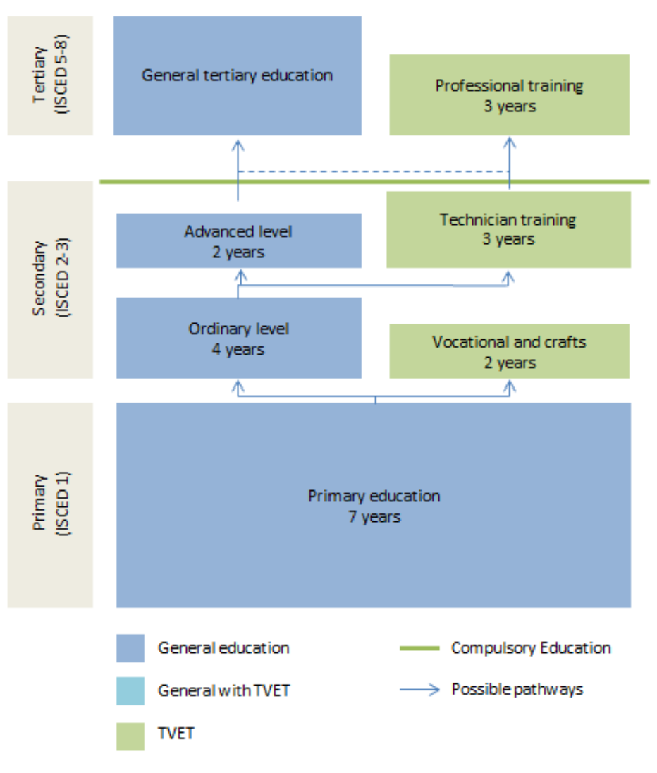
Source: Compiled by UNESCO-UNEVOC from UNESCO-IBE (2010). World Data on Education VII Ed. 2010/11. United Republic of Tanzania. Geneva: UNESCO-IBE.

The TVET sector faces challenges associated with poor training infrastructure and out of date equipment, inadequate training materials, facilities and qualified tutors. In addition, the poor institutional capacity and management of both public and private training providers is a persistent issue. Currently, few TVET institutions deliver skills training that address the employment challenges of poorly skilled young people, to help them move out of unemployment or informal low-skilled employment into decent work opportunities in their local labour market.
There are also issues associated with the recruitment and retention of students as enrolment rates are still low compared with market demand and an associated acknowledgment of the importance of promoting Tanzania’s TVET sector.

There is a need for strong links between TVET providers and employers in the development of programmes due to a mismatch between the skills being produced through the TVET system and those demanded by industry. This includes a need for the development of work placement opportunities for trainees and LMI to map the relevance and value of the training been offered. There is also an over-reliance of institutional based training, neglecting the importance of work-based learning, including through apprenticeships. Teaching is traditional and is slow to adapt to the changing demands of industry. Alongside mainstream TVET programmes there is also a need for more attention to short and tailor-made courses developed in collaboration with employers.

There is an identified need to increase Gender Equality and Social Inclusion (GESI) and the promotion of the TVET route to all is an integral part of the NSDS. There is also a severe gender imbalance in science and technology related programmes, whereby women learners in such programmes constituted only 11-19% in 2011/12 . There is also a concentration of TVET-provision in urban settings (about 75%), resulting in limited provision in rural areas.

The Initiative: ‘The Dual Apprenticeship Training System (DATS)
Background
DATS, launched in 2011, has been introduced to address the previously described challenges related to TVET relevance, quality and the acute need to further embed employers in training. DATS is a block release training system that has been developed in collaboration between VETA and the Hamburg Chamber of Crafts (HWK). HWK is a regional association representing 15,000 SMEs in Hamburg, Germany, with a mission to promote a strong and competitive skilled crafts sector, including through the delivery of international development programmes.

DATS is a three-year work-based Learning (WBL) training programme, delivered in four key sectors (automotive, electrical, hospitality and agro-mechanics). Although there is some disconnect between these sectors and those identified in the NSDS, DATS has been developed through an extensive consultation process and piloting to ensure its relevance to national skills priorities and context. The initiative is also planning to introduce training for jobs in additional sectors, including construction (masonry and brick laying, carpentry, painting, plumbing), and tourism (tour guide). DATS has recruited about 100 companies to support the WBL element and has recorded 200 apprentices finishing their training (June 2019), and a current cohort of 168 trainees.

DATS emphasises the value of WBL in supporting trainees towards employment and is delivered through trainees spending different periods, alternating between theoretical input at a VETA training centre and the workplace. The following overview of the programme’s structure is shared on the DATS website:

1st Block  Off the job training | Industry On the job  Training | 2nd Block  Off the job  Training | Industry  On the job Training | 3rd Block  Off the  Job Training | Industry on the job Training | TOTAL | Course Duration
7 weeks  VETA | 12 weeks  Industry | 7 weeks  VETA | 10N weeks  Industry | 6 weeks  VETA | 10 weeks industry | 52 weeks per year | 3 years

The industry placements are supported through MOUs signed between employers and partner VETA training centres. The DATS MOU includes confirmation of:
- Employers’ commitment to recruit apprentices following VETA guidelines,
- Application of apprenticeship contracts by employers and apprentices, which are submitted to and recorded at a VETA registration centre. This includes a guarantee to employ apprentices throughout the training programme period,
- Payment to apprentices to cover programme costs and expenses.
Assessment
To be assessed, learners must have completed all on-the-job and off-the-job blocks. Programme assessment focuses on learners’ practical competencies for their selected profession, alongside some theoretical examinations. On the successful completion of the programme, apprentices are awarded a national skilled trade certificate, which will help to map learners to wider qualification pathways and enhance their employment opportunities.
DATS Roles and Responsibilities
VETA
As part of its national training function, VETA's role under DATS is to ensure that institutional training is aligned and compatible with practical on-the-job training in the industry, including through:
- Proving practical, off-the-job training of apprentices in a VETA centre aligned with industry WBL elements of DATS,
- Providing qualified trainers to deliver centre-based input,
- Ensuring that training workshops are sufficiently resourced with equipment that aligns to trainees’ practical industrial placements,
- Coordinating and monitoring DATS programme implementation,
- Ensuring the availability of training materials and assessment tools,
- Providing English and IT skills relevant to the professional placement roles,
- Promoting the programme through national networks and stakeholders,
- Securing positive GESI outcomes.

HWK
- Overseeing the programme pilot to ensure DATS reflects local context,
- Promoting programme impact and sustainability,
- Technical support delivered through a Tanzania based international,
- Delivery of teacher trainer workshops by short term international experts,
- Financial and equipment support (EUR 250,00),
- Conducting workshops, in collaboration with VETA, with key industry stakeholders to ensure alignment between programme development and skills demand,
- Producing materials that promote and explain key elements of the dual system.

Employers
- Providing a working and learning environment,
- Assigning work-based mentors and assessors,
- Providing apprentices with an allowance (during on and off the job periods) to cover programme costs (transport, washing, meals etc.),
- Retaining trainees until they have completed their training (assuming their professional behaviour meets programme standards).
- Note: Employers can release apprentices at the end of the programme but retained apprentices are contractually obliged to remain with their company for two years.

Role and responsibilities
Through its national training role, VETA’s overall role in DATS is to ensure that institutionally based training is aligned and compatible to the practical on the job training delivered in industry, including by:
- Proving practical, off the job training of apprentices in a VETA centre aligned with industry WBL elements of DATS,
- Providing qualified trainers to deliver centre-based input,
- Ensuring that training workshops are sufficiently resourced with equipment that aligns to trainees’ practical industrial placements,
- Coordinating and monitoring of DATS programme implementation,
- Ensuring availability of training materials and assessment tools,
- Providing English and IT skills relevant to the professional placement roles,
- Promoting the programme through national networks and stakeholders,
- Securing positive GESI outcomes.
Roles and responsibilities
- Overseeing the programme pilot to ensure DATS reflects local context,
- Promoting programme impact and sustainability,
- Technical support delivered through a Tanzania based international,
- Delivery of teacher trainer workshops by short term international experts,
- Financial and equipment support (EUR 250,00),
- Conducting workshops, in collaboration with VETA, with key industry stakeholders to ensure alignment between programme development and skills demand,
- Producing materials that promote and explain key elements of the dual system.
Role and responsibilities
- Providing a working and learning environment,
- Assigning work-based mentors and assessors,
- Providing apprentices with an allowance (during on and off the job periods) to cover programme costs (transport, washing, meals etc.),
- Retain trainees until they have completed their training (assuming their professional behaviour meets programme standards),
- Employers can release apprentices at the end of the programme but retained apprentices are contractually obliged to remain with their company for two years.
Pros and Cons
Pros
- The introduction of dual system models, through DATS, will address current challenges associated with training relevance and industry participation. Good practice developed through DATS in these areas will have a wider impact on the VETA-system and network
- The use of extensive piloting, supported through international expertise and consultative workshops, will help to ensure that the programme has been developed to reflect local context and need. This is particularly essential in consideration of some of the delivery challenges associated with the implementation of the dual system.
- The use of end-point assessment to ensure that the apprentices have acquired the target competencies will support alignment with skills needs and the transition from training to employment. The use of a national skills certificate to verify DATS graduates’ learning will help to map it to other TVET pathways and outcomes.
- The use of an apprenticeship contract, with a financial contribution from employers, to guarantee employment throughout the training programme (both during on and off the job training) will promote apprentices’ recruitment, achievement and retention. This is particularly important due to the relative length of the programme. It will also encourage employers’ long-term commitment to the programme and their apprentices.
- DATS is a long-term programme (three years) which will allow for the fuller development of range of apprentices technical and employability skills. The opportunity to access WBL through the programme will support the development of learners’ soft skills (company values, work ethics etc.)
- DATS provides a strong platform to promote positive TVET sector messages, as illustrated through the stories captured on the programme’s website https://hwkdualsystem.co.tz/news/. DATS, through its website, also provides a forum through which videos and information on the dual system can be disseminated.
- VETA’s key role in DATS will support wider impact and alignment with TVET sector programmes and pathways.
- The innovative use of a block release system will support programme enrolment by enabling VETA centres to recruit new apprentices.
- The programme will support VETA in taking ownership of WBL policy and practice. Although the guidelines borrow from international TVET concepts, the initiative has distinct Tanzanian features and focus, which should facilitate commitment and engagement from different stakeholders.
- The guidelines are aligned with identified needs in terms of increased job placements, relevance and credibility, quality, stakeholder collaboration and employer engagement. In this regard, they can be seen as an innovative approach to the operationalisation of the Government of Tanzania’s strategic objectives.
- The guidelines start to define what is meant by an apprenticeship, including referencing payment and contracts (agreement) between key stakeholders. The defining of apprenticeships, linked to funding, will help to embed a shared understanding of quality WBL models and responsibilities. The setting of a three-year period for an apprenticeship will also ensure that they are viewed as a long term and significant programme and qualification.

Cons
- The presented programme information provides an overview of roles and responsibilities; however, it would be valuable if requirements were further explained through example contracts and associated documents. This would help stakeholders’ understanding of dual system features.
- The programme has made some impressive progress (including 200 graduates), however, there remains an inherent challenge of how dual system models can be delivered at scale in the context of developing economies. The collaboration with VETA will support wider uptake, and the commitment to a local approach is also very important, but there remain problems with achieving impact through recruitment.
- The programme references the importance of inclusion and embedding GESI values but there is a lack of clear inclusion approaches, targets or incentives.
- It is not clear how programme funding is being linked to quality assurance monitoring and apprentices’ outcomes, including using key metrics to measure enrolment, retention, progress, achievement and employability.
- The programme does emphasise employer commitment to employing apprentices for the duration of their training, however, it doesn’t appear to specify other key requirements associated with working conditions, termination terms and health and safety, and trainee wellbeing. This includes limiting the number of apprentices employed in higher risk roles.
- There is a need for further information on how stakeholders’, including employers’, capacities will be built to deliver their programme roles.
- It would be valuable to have further information on how programme implementation is quality assured, monitored and measured.
- The delivery of DATS will require VETA resource, expertise and expense. It will be essential that the VETA is appropriately funded and resourced to deliver its role.
- The initiative is dependent on development funding and additional activities will be required to secure employer participation on a scale that would make it a sustainable model.

Positive outcomes and testimonials
- The programme website references that; ’After 4 years the 3- year block release apprenticeship format is functioning extremely well and all partner companies are extremely satisfied with the quality of training.’
- In media communications (The Citizen newspaper, October 2021), the VETA Director General, Dr Pancras Bujulu spoke about how; ‘Implementation of Phase One of the DATS in agro-mechanics at Manyara RVTSC has been very successful. The number of companies participating in the programme has increased from two when the Program commenced to more than ten now, and the trend is on the increase’

Source:

- https://www.thecitizen.co.tz/tanzania/news/business/german-chamber-veta-partner-in-apprenticeship-project-3604032 (October 2021)
- Determinants for positioning and promoting TVET in Tanzania: Information for developing a marketing strategy (2016) Mulongo, G., Kitururu, I., & Irira, M
- https://hwkdualsystem.co.tz (last accessed 2nd September 2022)
- Labour Market Information for Skills Development Capacity Building Plans (2019-2022) Skills for Employment Tanzania, SwissContact
- NACTVET website https://www.nacte.go.tz/index.php/about-us/who-we-are/ (last accessed August 31st 2022)
- Skilling Tanzania: Improving financing, governance & outputs of the skills development sector (2018), Andreoni, A. SOAS
- Skills for Development Fund Proposal (2017), Tanzanian Education Authority
- Tanzania Education sector analysis (2010), UNESCO
- United Republic of Tanzania, Ministry of Education and Vocational Training, Relevance of TVET to Market demands: Skills for Employability (2010) Manyaga, T.N.P, Athumani, A
- VETA website https://www.veta.go.tz/about-us (last accessed 1st September 2022)
- World TVET database – Tanzania (2016) UNESCO-UNEVOC

Disclaimer: This publication was produced with the financial support of the European Union and the German Federal Ministry for Economic Cooperation and Development. The views and opinions expressed herein are those of the authors or persons cited and do not necessarily reflect the official policy, view or position of AUDA-NEPAD, the European Union or the German Federal Ministry for Economic Cooperation and Development. The terms used herein and the presentation of material therein do not imply any endorsement by AUDA-NPAD, the European Union or the German Federal Ministry for Economic Cooperation and Development. Information in this book is offered in the understanding that it does not contain legal, financial or other forms of professional advice. Although the author has made great efforts to ensure the accuracy of the content, errors and omissions may occur.
Throughout this report the abbreviation of Tanzania will be used
World TVET-database – Tanzania (2016) UNESCO-UNEVOC
Ibid
Skills for Development Fund Proposal (2017), Tanzanian Education Authority
https://www.tra.go.tz/index.php/skills-development-levy-sdl
NACTVET website https://www.nacte.go.tz/index.php/about-us/who-we-are/
VETA website https://www.veta.go.tz/about-us
World TVET-database – Tanzania (2016) UNESCO-UNEVOC
Swisscontact - SET
Mulongo et al
SOAS
UNESCO
Manyaga et al
Ibid
https://hwkdualsystem.co.tz (DATS-website)
https://www.veta.go.tz/dual-apprenticeship (VETA-website)
Ibid
https://hwkdualsystem.co.tz/wp-content/uploads/2018/03/Brochure-dual-apprenticeship-2018.pdf
Ibid
https://www.thecitizen.co.tz/tanzania/news/business/german-chamber-veta-partner-in-apprenticeship-project-3604032
https://www.thecitizen.co.tz/tanzania/news/business/german-chamber-veta-partner-in-apprenticeship-project-3604032

