The Initiative: Using Local Artisans for Training of Apprentices

Initiative | Using Local Artisans for Training of Apprentices
Initiative focus | Selecting youths as trainees/apprentices and providing them with life skills training (aimed at improving their self-confidence/esteem which is necessary for learning) as well as political empowerment awareness training;  Selecting artisans to take on apprentices as trainees and providing them with tools and equipment required
Target group | Potential apprentices - vulnerable youths challenged with limited formal education (school dropout)s, no vocational skills, family issues;  Artisans

Save the Children Denmark implemented several youth projects called Education for Youth Empowerment (EYE) in the East African area. The EYE projects offered a holistic approach, which focused on multiple aspects of youths' needs by combining social, economic and political empowerment of youth. The three empowerment areas are mutually underpinning and supporting and are bowering from other thematic areas such as child rights governance, protection, basic education and livelihood.
Empowerment was approached as a process of increasing the knowledge, skills and ability of individuals or groups to make informed choices and transform them into desired actions improving their livelihood. The youth empowerment process should take its point of departure in the development of the social empowerment skill and knowledge, which focus on youth's situation and the realities affecting them. Political empowerment is aimed at increasing young people’s ability to individually and/or in cooperation with other youths and civil society organisations to advocate for the fulfilment of their rights at local, district and national levels and thereby make sustainable changes that, among other things, can strengthen their livelihood.
Economic empowerment is the process of increasing youth’s ability to bring about positive economic changes for themselves on either an individual or a group level. The economic empowerment skills and knowledge are gained through interlinked activities like non-formal basic education, technical-vocational skills development, apprenticeships and entrepreneurship training and employability training. Furthermore, employment support (wages and self-employment) linked to access to start-up capital and savings enable youth to make a safe transition from learning to earning. The three empowerment areas are mutually supportive which offers a multi-dimensional approach to addressing youth livelihood challenges. A model, with minor variation, is used by many national and international NGO’s.
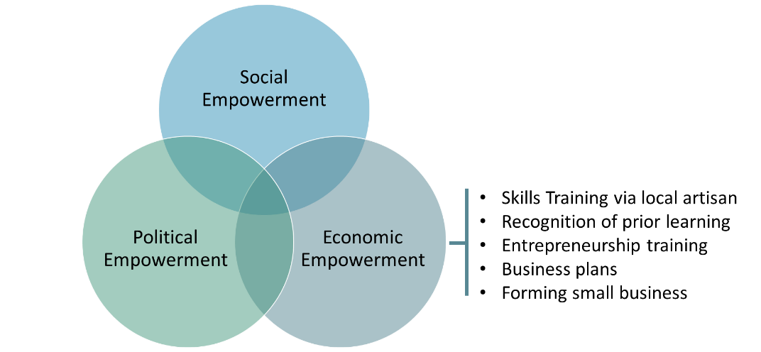

The initiative: Using local artisans for training of apprentices
In the context of economic empowerment, vulnerable youth was offered vocational skills training. Some youth at local formal TVET providers other at local artisans in a form of apprenticeship or internship schemes.
In the geographic area, the EYE project covered local artisans (single artisans or an artisan having one or two workers), performing above average, were approached to engaging in the training of a few trainees. In exchange for passing on their craft, the local artisans would be offered relevant equipment (hand tools) and training consumables to train x number of trainees. Artisans were also offered to keep the equipment after training of x cycles of trainees and some would also be introduced to basic pedagogics. The training was structured as on-the-job training where the trainees would participate in the normal production/activities at the artisan gradually increasing the complexity of the learning as the trainees mastered the skill of the trade. After the training period, which could vary depending on the vocation, the trainees could sit for a recognition of prior learning (RPL) test. This would be subject to the existence of an RPL facility within the formal TVET system.
Besides the vocational training, youth was offered life skills training and political empowerment activities. Establishing a network and smaller groups of trainees are encouraged and supported for mutual support, facilitating learning and building individual self-confidence. The networks and groups were also used to form business groups of youth agreeing to start a small business together. To further facilitate the establishment of small businesses the trainees were offered entrepreneurship and business start-up training which included an introduction to micro-credit facilities.
The figure below shows the overall steps with a focus on the apprenticeship/internship skills training elements.
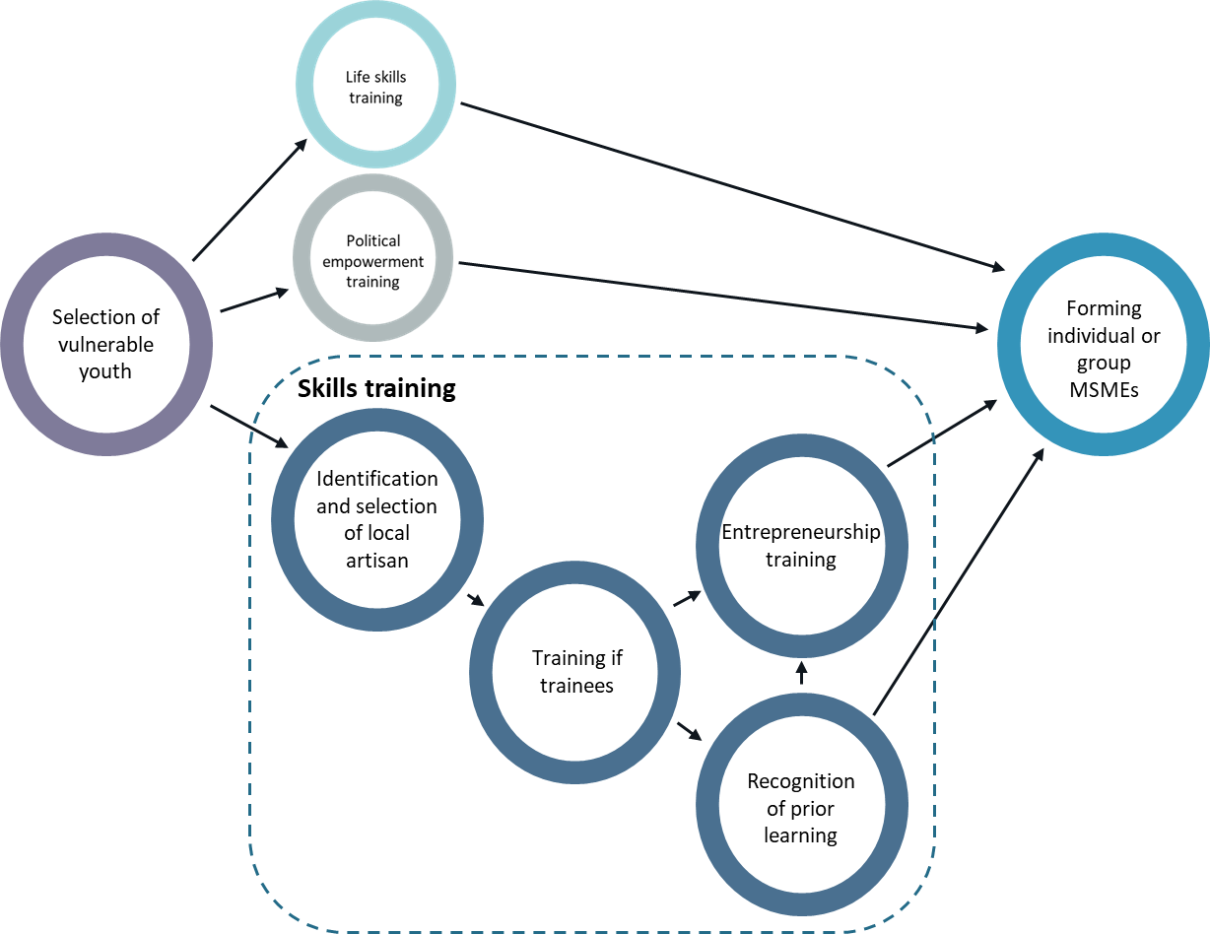
The target group will be vulnerable youths challenged with limited formal education (school dropout), no vocational skills, family issues (no close family members, child of a single parent, young mothers etc.) poverty, and low self-esteem.
Once the selection of the youth is finalised, the trainees will be offered life skills training aimed at improving their self-confidence/esteem which is necessary for learning. Similarly, the trainees will receive political empowerment awareness training.
The skills training will include guidance on the relevant vocation for each trainee. This will be a combination of individual wishes and possible community business opportunities. The project may include a youth-based market assessment as part of the clarification of which training will be relevant to the individual trainee. Any family support the trainee may receive will also be considered. This could be any vocational understanding/experience or small scale business experience of family members, the possibility of childcare as well as funds for investing in a small business.
Once the vocations of the skills training are clarified, local artisans are identified and selected by applying a standardised identification and selection tool and process.
As part of the identification and selection process, the local artisans are informed about the entire project and their role in taking on a trainee/apprentice which will include training and coaching responsibility, reporting to the relevant NGO on the progress made as well as the wellbeing of the trainees.
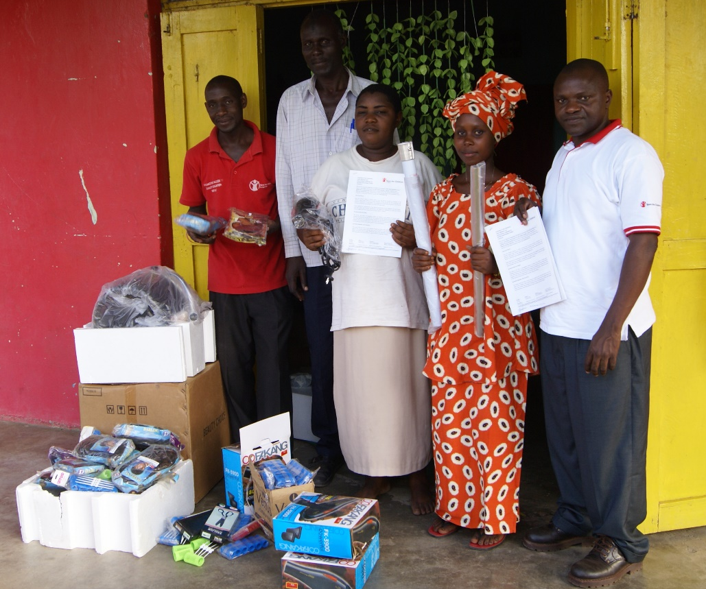
A local hairdresser (centre holding the engagement contract) participating in the training of youth. She is receiving the necessary equipment for the training of trainees. One of the trainees can be seen second from right.
To facilitate the process representatives of the community participated (second from left) along with Save the Children staff.
Photo: Søren Bo Poulsen
In exchange for providing training to the trainees/apprentices, the local artisans will receive additional hand tools, minor equipment and training consumables. The support will be scaled to the number of trainees each local artisan has taken on and the hand tools/equipment the artisan already has got. After the training of an agreed number of trainees/apprentices, the artisan can keep the tools and equipment. The artisans might also be offered basic pedagogical training and will become a member of a network of artisans that may be invited to selected events such as the graduation of trainees, general meetings with TVET providers on the possibility of recognising the learning and/or meetings with the local authorities aimed at promoting skills training and business possibilities of youths.
The artisans will also be able to benefit from the trainees' production and service work - an advantage that is expected to become clearer the more the trainees learn. A hairdresser may be able to take on more clients because the trainees can attend to the extra clients.
During the training, the artisans will be visited by the NGO to discuss the trainees’/apprentices’ progress, their attendance and other training-related issues. The visits also serves the purpose of showing interest in the training provided by the artisans and that their participation is valued.
Vulnerable youths will not have the time or funds to engage in long-term skills training because they contribute to the household income. Consequently, many trainees are interested in gaining a level of skills that could lead to employment or self-employment/start their own business.
After the training, trainees might have the possibility and wish to take an RPL test and receive a formal certificate. This will depend on the RPL facilities which the formal TVET system offers. An RPL possibility should also be discussed with the local TVET providers well in advance.
To facilitate that trainees can start their own business – either individually or as a group business – the trainees will be offered entrepreneurship training. The main part of the training will focus on developing bankable business plans and identifying youths that wish to develop a business plan and start up a small company together. Having access to microloans is crucial for the realisation of youths’ business plans, which is why establishing links to micro credit schemes is important, at best, during the entrepreneurship training. It is at this point that the skills training is followed by business and employment facilitating activities.

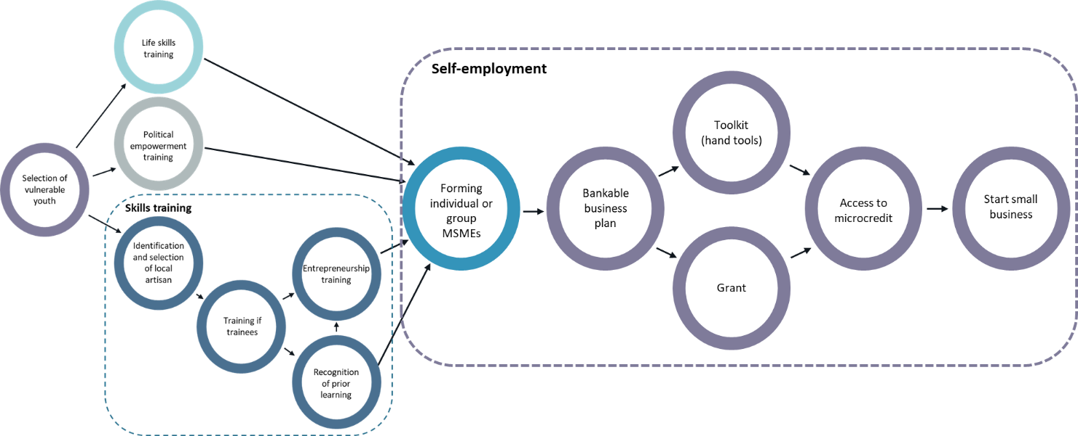
Some models offer start-up hand-tools (tool kit) to facilitate the transfer from training to self-employment. Within the EYE team, it was discussed how best to facilitate the transfer to self-employment and to facilitate access to microcredits. It was discussed to replace the cost of the toolkit with a financial deposit in the form of a grant that would improve the creditworthiness of youths. The youths' business plans often require 100% funding through microcredits. To strengthen their creditworthiness the cost of a toolkit can be changed to a grant, thereby reducing the need for funding. This would be attractive for small businesses having two to seven members because the grant would be the value of two to seven toolkits representing a relatively high amount with regard to the total financing need. Other projects will also facilitate saving and loan activities to facilitate self-employment.
Pros and cons of the initiative
Pros
Engaging local artisans is building on the existing informal apprenticeship model where local businesses traditionally offer apprenticeship options to young people. The concept that local artisans take on trainees/apprentices is therefore not new to the artisans, the parents, the youths and the community in general. Instead, the concept takes advantage of the existing informal apprenticeship tradition by engaging artisans in a new way where they become part of combined initiatives addressing the needs of vulnerable youths. With an RPL facility in place, trainees can get formal recognition of acquired skills. This will not only motivate trainees but also facilitate finding employment.
Engaging local artisans mobilises skills training opportunities where the youths live and thereby addressing skills access challenges. The youths will not have to commute to and from the nearest TVET school which is located farther away than the local artisans. This is attractive because it limits the transport time and costs. In addition, boarding at a TVET school is financially not feasible for many young people, especially vulnerable youths.
Especially for youths living in rural areas, having access to local skills training will be an advantage. It will also increase young girls' access to skills training. Parents are often reluctant to let their daughters move to a larger town where TVET schools are often located for skills training because their limited resources are spent on their sons’ education/training and fearing that their daughters will become pregnant. Furthermore, offering local skills training opportunities may address migration to larger towns because youths will see local training and employment opportunities instead of deciding to migrate to find employment or to postpone migrating before they have basic skills making them more employable.
Utilising local artisans for skills development is cheaper than bringing rural youths to a TVET school. The cost of training (equipment, consumables, training fee, transport, board and lodging, etc.) and other associated costs (for example management costs) are lower compared to similar long-term training at a TVET school.
In some cases, the local artisans have strengthened and/or grow their business in the local market. This is partly because of the attention given by the project to the artisans which translates into the local community's positive perception of the local artisans’ skill and business. The role of an artisan as trainer, having responsibility for the training of youths, often brings out the best in the local artisan refining their craft and structuring their business better. In addition, being selected to be part of the project and being offered to participate in different activities/events are building their confidence.
Cons
The trainees' levels of learning are limited to the knowledge, attitude and skills of the artisans. This limits how high a learning level the model can offer. The model will also not drive innovation and productivity. However, its actual purpose is to give vulnerable youth realistic/better employment prospects.
Local artisans have mentioned that training youths in their craft may mean to ‘train their competitors’. This is a valid concern that employers also have raised towards larger formal apprenticeship initiatives/programmes. These concerns can be challenging to address, but the close connection to the existing informal apprenticeship system helps to tackle the articulated concern as it is not significantly different.
Being part of a project will require sharing some business information necessary for assessing the appropriateness of engaging the local artisan for example. Some artisans are hesitant to share such information of the fear of being subject to increased government control, tax and fee.
Ensuring that trainees/apprentices receive a recognised certificate is a concern that almost all apprenticeship initiatives/programs share. Engaging local artisans through the above model will not necessarily lead to a formal certificate. Being able to offer a recognised certificate will depend on whether RPL is an integral part of the formal TVET system and whether RPL is a realistic option for the trainees in terms of formal requirements, cost and practical arrangements. Again, the model of engaging local artisans was not designed with the purpose that trainees should obtain a recognised certificate but to facilitate their employment/self-employment chance as part of their empowerment.
Testimonial
Cynthia, Uganda
Cynthia, 21, lives in Uganda, with her grandmother and her two younger siblings. After her father was jailed, she dropped out of school as she couldn’t get by. Her mother is in South Sudan working but not sending any money. She joined the Youth Empowerment Bvlgari programme in 2017. She received from Save the Children a start-up kit composed of a sewing machine, leather and fabric, and worked with a group of five peers. Thanks to the training in leatherwork, she learned to make purses and shoes. Soon she began making items alone and saving money to set up her own business, she got a loan and bought another sewing machine and some materials to differentiate her work. Some of her mates got interested in the same production, and so she started teaching them. Save the Children, thanks to Bvlgari donation, supported her work again and provided more materials. One of her students was a boy, a major gender barrier breached thanks to the YEB programme.
Cynthia said: “I’m a stubborn girl. You must struggle for your dreams. Everything I own comes from the efforts in the leather business, a gift from Bvlgari and Save the Children.”
Cynthia today can help her mother and pay for her siblings’ education. The programme also supported her to become a youth advocate. She fights to stop early marriages and youth unemployment. She can talk effectively on behalf of her peers.
“I’m not afraid of doing it. Not anymore”. In Uganda, currently, every ten minutes one under-age girl gets married. In 2019, for instance, Cynthia spearheaded a petition to fight child marriages, during the Annual Youth Conference, signed by the leaders of the main districts.
Note: The testimonial is not from a participant of the described EYE project but from the ‘Youth Empowerment Bulgari’ Uganda applying a similar approach. See ‘Youth Empowerment - Providing youth with life skills and job training’ Save the Children. https://resourcecentre.savethechildren.net/pdf/youth_empowerment_bulgari_project_-_annual_report_bulgari_2020.pdf/
Source:
‘A youth participation best practice toolkit. Part one: What to consider when designing youth participation programmes aimed at the social and civic empowerment of vulnerable youth’ by Lotte Ladegaard. Save the Children, Denmark. 2016. https://resourcecentre.savethechildren.net/document/youth-participation-best-practices-toolkit-part-i/
‘A youth participation best practice toolkit. Part two: Tools, methods, tips, exercises and suggested training workshops for youth participation programmes and projects aimed at the social and civic empowerment of vulnerable youth’ by Lotte Ladegaard. Save the Children, Denmark. 2016. https://resourcecentre.savethechildren.net/document/youth-participation-best-practices-toolkit-part-ii/
‘Youth Empowerment - Providing youth with life skills and job training’ Save the Children. https://resourcecentre.savethechildren.net/pdf/youth_empowerment_bulgari_project_-_annual_report_bulgari_2020.pdf/
It should be noted that the approach presented is an earlier variation of what is presented in the above two publications.

Disclaimer: This publication was produced with the financial support of the European Union and the German Federal Ministry for Economic Cooperation and Development. The views and opinions expressed herein are those of the authors or persons cited and do not necessarily reflect the official policy, view or position of AUDA-NEPAD, the European Union or the German Federal Ministry for Economic Cooperation and Development. The terms used herein and the presentation of material therein do not imply any endorsement by AUDA-NPAD, the European Union or the German Federal Ministry for Economic Cooperation and Development. Information in this book is offered in the understanding that it does not contain legal, financial or other forms of professional advice. Although the author has made great efforts to ensure the accuracy of the content, errors and omissions may occur.

