Mapping apprenticeship initiative that facilitates the implementation of work-based learning

‘Using Local Artisans for Training of Apprentices’
Tool | Guidelines for Selection of Local Artisans
Tool focus | This tool is aimed at structuring the identification and selection of local artisans (Masters Craftsmen) for their engagement in work-based learning such as apprenticeship, internship, industrial attachment etc.
Target group | Public TVET local/national authorities and NGOs selecting local artisans for an internship, industrial attachment or informal master craftsmen.  Local artisans (Master craftsmen) engage in work-based learning activities.

The Programme: Education for Youth Empowerment, Save the Children, Denmark
Save the Children Denmark has implemented several projects for the Education for Youth Empowerment (EYE) programme in the East African Area.
The EYE projects offered a holistic approach, which focused on multiple aspects of youths' needs by combining the three pillars of social, economic and political empowerment. The three pillars are mutually underpinning and are supported by other thematic areas such as child rights governance, protection, basic education and livelihood.
Empowerment was approached through the process of increasing the knowledge, skills and ability of individuals or groups, to make informed choices and transform them into desired actions, thus improving the livelihood of young people. The youth empowerment process should start with the development of social empowerment skills and knowledge, which in turn should focus on the youth's situation and the realities affecting them. Political empowerment aims to strengthen the capacity of young people to advocate individually and/or in collaboration with other young people and civil society organisations for the assertion of their rights at local, district and national levels, and thus to bring about sustainable changes that can, among other things, strengthen their livelihoods.
Economic empowerment is the process of increasing youth’s ability to bring about positive economic changes on either an individual or a group level. The economic empowerment skills and knowledge are gained through interlinked activities, such as non-formal basic education, technical-vocational skills development, apprenticeships and entrepreneurship training and employability training. Furthermore, employment support (wages and self-employment) linked to accessing start-up capital and savings enable young people to make a safe transition from learning to earning. The three empowerment pillars are mutually supportive, which offers a multi-dimensional approach to addressing youth livelihood challenges. This three-pronged approach – with some degrees of variation – is used by many national and international NGOs.
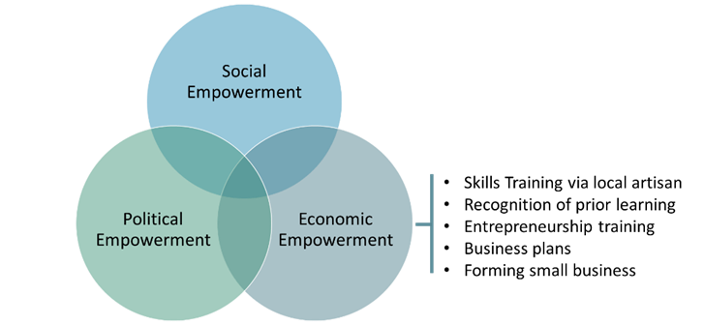
In the context of economic empowerment, vulnerable youth were offered vocational skills training, either through local TVET providers or other local artisans in the form of apprenticeship or internship schemes.
The EYE project involved local artisans in certain geographical areas (individual artisans or an artisan with one or two employees) who performed above average and were willing to participate in the training of a few trainees. In return for sharing their craft, the local artisans received appropriate equipment (hand tools) and consumables for training a certain number of trainees. The artisans were also offered to keep the equipment after training a target number of trainees and some would also be introduced to the basics of pedagogy. The training was structured as on-the-job training, where the trainees participated in the normal production/activities of the craft workshop, with the complexity of the learning gradually increasing as the trainees became more proficient in the skills of the craft. After the training period, which varied depending on the trade, trainees were able to sit an exam to formally recognise what was learnt previously. This was dependent on whether there was an RPL facility within the formal VET system.
In addition to vocational training, young people were also offered life skills training and political empowerment activities. The formation of networks and smaller groups of trainees was encouraged in order to support each other, facilitate learning and increase individual self-confidence. The networks and groups were also used to form business groups of young people who agreed to start a small business together. To further facilitate small business start up, the trainees were offered training in entrepreneurship and business ventures, which included an introduction to micro-credits
The Tool: Guidelines for Selection of Local Artisans
The selection of relevant local artisans was vital to the outcome of the vocational skills training. Experience has shown that the local non-governmental organisations (NGOs) operating in the geographical area concerned took a very different approach to selecting local artisans. Therefore, it was important to structure the selection process. The EYE Guidelines for Selection of Local Artisans guidelines were developed with the purpose to assist Save the Children’s local partners (local NGO) with regards to:
- Identifying and selecting local artisans in order to engage them in the training of young people;
- Ensuring structure and quality in the selection process.
The guidelines in the form of a written document included (i) an introduction to the guidelines, (ii) a presentation of the selection criteria (iii) how to use the guidelines and (iv) interview guidelines for interviewing local artisans.
The guidelines were presented to the relevant staff of the local NGOs supporting Save the Children in the implementation of EYE projects. The local NGOs were responsible for applying the guidelines through a systematic process of visiting local communities to inform the artisans about the EYE projects, the training model, the involvement of local artisans including roles and responsibilities, and the conditions offered to the selected artisans. Save the Children was responsible for developing and adapting the guidelines and for their general application. This would include any reports mentioning the selection of local artisans.
The outcome of the identification and selection process was fed back to Save the Children and, in collaboration with local NGOs, the final selection was made, after which the artisans were informed. As can be seen from the guidelines, they are general in nature, as the guidelines apply to very different communities and are intended to allow for application according to local circumstances.
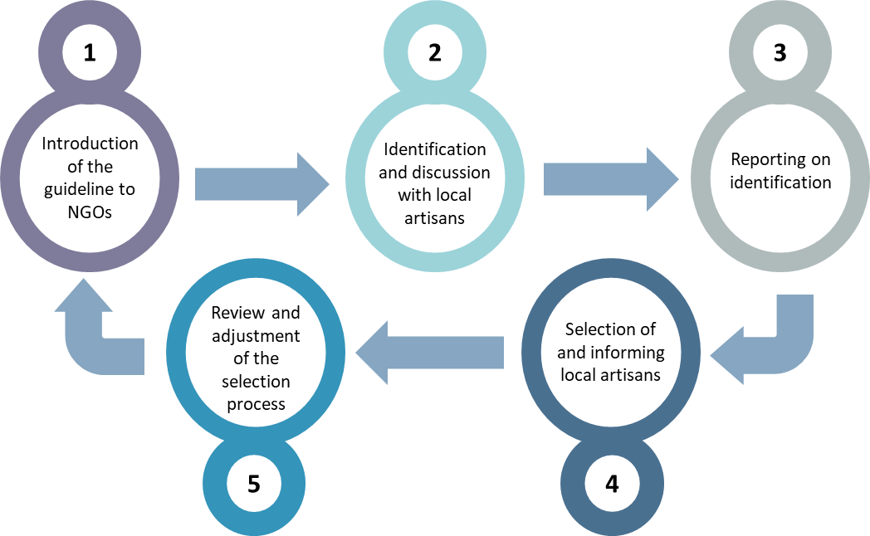
Figure 1: The guidelines’ application process
The process of applying the guidelines outlined above would include at least one person for each of the local NGOs, an introductory meeting, community visits, reporting and review meetings. All activities were not carried out separately but integrated into other project meetings.
The signature of the NGO staff and artisan serves to ensure that the artisan has been well informed before engaging in the training of trainees. The signed document would stay with the artisan and with Save the Children/the local NGO.
The profile and training/career wishes of the target group – vulnerable youth – determined within which business/vocations local artisans would be identified and finally engaged. Therefore, the guidelines were introduced as soon as the profiling and carrier guidance process of the youth was initiated giving an indication of which local artisans to engage.

EYE Guidelines for Selection of Local Artisans
Background
Below are guidelines that can be used for selecting local artisans for EYE skills training activities.
The main objective of the guidelines is to ensure that the selection of artisans is done in a structured way and that key learning aspects are taken into account. It is also important that artisans are fully informed about the process, roles and responsibilities, and the basics of Save the Children's work and principles.
The quality of training is assessed through observation by the interviewer and through discussions with current and former trainees. The number and quality of tools/equipment will be reviewed.
Selection Criteria
Seven general criteria were identified and the main concerns they should cover are described by seven simple questions that the identified local artisan should answer.
Criteria | Explaining questions
The number of youths/learners: | How many youth/learners can an artisan safely have both in terms of learning outcome and for safety considerations?
General craftsmanship: | Has the artisan a sufficient level of craftsmanship necessary to function as a teacher?
Level of business: | Has the artisan enough business to be considered a relevant place of skills training?
Teaching experience: | Has the artisan sufficient teaching experience to function as a facilitator for vulnerable youth?
Location of the local artisan: | Is the artisan at a place that is accessible for the learner?
Awareness of SC’s foundation and policies: | Is the artisan aware of the foundation on which SC is working?
For each criterion, a note is given on how to apply it and a suggestion on what to look for.
It is important that the guidelines are applied with an understanding of the context within which the artisan is to provide learning. This means that other elements can be considered and that the importance of each element may vary according to the local context. As a result, additional criteria might need to be added to the guidelines.
Selection Guidelines
Criteria | Principle | What to look for?
Age of the artisan | The artisan should have an appropriate age that can facilitate teaching | Simply determine the age of the artisan and assess whether or not it is an appropriate age. Consideration should be given not to have too young or too old artisans compared to the learners.  If it is a group of artisans then consider the age structure of the group.
Number of youths/learners | A single artisan can only have a maximum of 5 youth learners | The place of learning:  - Should not represent any health risks to the learners;  - Be large enough to accommodate max 5 learners (everyone should be able to follow [see & hear] instructions);  - The nature of the trade should be considered when assessing the number of learners. Some skills require more space for obvious health reasons.
 | The placement of learners at a group of artisans cannot exceed 10 | If the local artisan is a group (two or more), up to 10 learners can be placed with the artisan at the same time.  The same considerations applied to a single artisan should be applied to a group of artisans
General craftsmanship | Only artisan with an above-average level of craftsmanship can be selected | The craftsmanship of the artisan:  - Any formal certificates (should be verified);  - Years of practicing the craft as self-employed or employed (should be verified);  - Whether or not it is the main income;  - Quality and quantity of tools and/or equipment;  - General reputation.  If it is a group of artisans then consider the group as an entity meaning that the group’s joint craftsmanship should be considered.
Level of business: | The artisan should have a reasonable level of business within the trade to represent a relevant place of learning | Level of business:  - The artisan should have regular business activities within the trade to provide good learning opportunities;  - The business activities should be of a diverse nature enabling the learners to learn as many aspects of the trade as possible.  If it is a group of artisans then consider the groups’ level of business.
Teaching experience: | The artisan should at best have some teaching experience or at least be willing to attend a teaching course | Teaching experience:  - Any formal teaching experience (should be verified);  - Prior teaching experience;  - Have had trainees before;  - Willingness to go on a teaching course.  If it is a group of artisans then consider the groups’ teaching experience.
Location of local artisan | The artisan’s place of business/learning should be accessible for the learners | The place of learning:  - Most not within a reasonable distance (one hour walk to and from) from the learners;  - Be large enough to accommodate max 5 learners (everyone should be able to follow [see & hear] instructions).  If it is a group of artisans and their activities are split over different locations then consider the accessibility of all the locations.
Awareness of SC’s foundation and policies | The artisan should at least be informed about SC’s policies and concur with them | Is the artisan:  - Aware of SC’s policies;  - Accepting to work in accordance with SC’s policies.  It will be necessary to provide each artisan with an understanding of and information (material) regarding SC’s policies. It will also be relevant to have the artisan sign that he/she has been informed and understands SC’s policies. This could be part of the MoU to be signed.  For a group of artisans, each member should be aware and accept and work in accordance with SC’s foundation and policies.

How to apply the guidelines?
The local artisan should be visited and through an interview and observations, all the above principles should be assessed following a simple interview/selection format (overleaf).
Before the interview, the artisan should be informed about the purpose of the assessment, which is to determine:
- Whether or not vulnerable youth can be placed for skills training in a meaningful manner and ;
- Which assistance SC can provide in terms of hand tool, information or training;
- Provide the artisan with all the relevant information (roles, responsibilities, procedures, MoU and payment etc.).
The result of the assessment should be communicated immediately after the assessment to the artisan for comments. The comments should be noted and the assessment format should be signed both by the artisan and the interviewer.
The next step in the process should be made clear to the artisan.
Selection and interview format
For each of the six criteria, the artisan is interviewed. The interview and observation should satisfactory cover the areas mentioned under “What to look for?” in the guideline framework. Answers and observations are recorded under “Feedback & Observation”.
Criteria | Principle | Feedback & Observations
Number of youths/learners | A single artisan can only have a maximum of 5 youth learners
 | The placement of learners at a group of artisans cannot exceed 10
General craftsmanship | Only artisan with an above-average level of craftsmanship can be selected
Level of business: | The artisan should have a reasonable level of business within the trade to represent a relevant place of learning
Teaching experience: | The artisan should at best have some teaching experience or at least be willing to attend a teaching course
Location of local artisan | The artisan’s place of business/learning should be accessible for the learners | Write the exact location and contact details.
Awareness of SC’s policies | The artisan should at least be informed about SC’s policies and concur with them | The artisan has to be introduced to SC's policies  The artisan has to be given SC's materials  The artisan concur to work with SC’s policies

Date: |  | Date:
Artisan: |  | Interviewer:
Signature: |  | Signature:

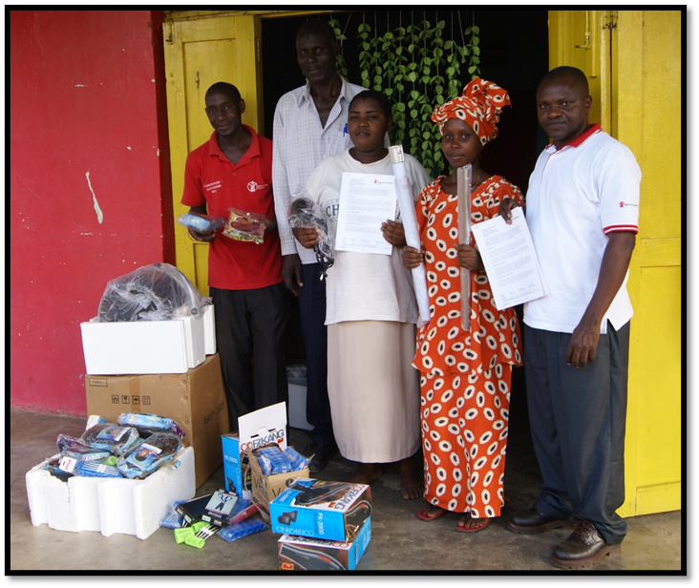
A local hairdresser (centre holding the engagement contract) participating in the training of youth. She is receiving the necessary equipment for the training of trainees. One of the trainees can be seen second from right.
To facilitate the process representatives of the community participated (second from left) along with Save the Children staff.
Photo: Søren Bo Poulsen

Pros and Cons
Pros
- The advantage of the tool is that it addresses its purpose, namely to engage local artisans for the empowerment of youth through apprenticeship, in a clear and structured manner by offering a relevant degree of standardization to a process that, otherwise, could be addressed differently. At the same time, the tool is not so complex that it would be difficult to use. It can be easily used on site in both a paper version and a PC offline version. This also implies that it is not a costly tool to apply nor to maintain.
- Applying a structured local artisan identification and selection tool will facilitate the evaluation of the entire skills development programme by providing information on the process of selecting local artisans. This will make it possible to constantly upgrade the selection of local artisans for the benefit of the skills development and in turn facilitate the employability of the trainees.
Cons
- The tool does not have many disadvantages due to its simplicity. However, as many of the local artisans are operating in the informal economy -partly or fully - there is a natural scepticism about providing information about their business because artisans are worried that such information will be used to collect additional taxes and fees.
- As the whole programme and thus the tool is part of the NGO activities, local artisans are likely to be less concerned. However, it is important to provide local artisans with information about the objective of the entire programme, the relevance of the tool and how the information will be used. That is to say that transparency towards the local artisan also when applying such a simple tool is necessary and can facilitate the entire implementation of a skills development project.
Source:
- ‘A youth participation best practice toolkit. Part one: What to consider when designing youth participation programmes aimed at the social and civic empowerment of vulnerable youth’ by Lotte Ladegaard. Save the Children, Denmark. 2016. https://resourcecentre.savethechildren.net/document/youth-participation-best-practices-toolkit-part-i/
- ‘A youth participation best practice toolkit. Part two: Tools, methods, tips, exercises and suggested training workshops for youth participation programmes and projects aimed at the social and civic empowerment of vulnerable youth’ by Lotte Ladegaard. Save the Children, Denmark. 2016. https://resourcecentre.savethechildren.net/document/youth-participation-best-practices-toolkit-part-ii/
- It should be noted that the approach described is an earlier variation of what is presented in the above two publications. The EYE Guidelines for Selection of Local Artisans was developed in the process of implementing a Save the Children, Denmark project in Western Uganda by Søren Bo Poulsen.

Disclaimer: This publication was produced with the financial support of the European Union and the German Federal Ministry for Economic Cooperation and Development. The views and opinions expressed herein are those of the authors or persons cited and do not necessarily reflect the official policy, view or position of AUDA-NEPAD, the European Union or the German Federal Ministry for Economic Cooperation and Development. The terms used herein and the presentation of material therein do not imply any endorsement by AUDA-NPAD, the European Union or the German Federal Ministry for Economic Cooperation and Development. Information in this book is offered in the understanding that it does not contain legal, financial or other forms of professional advice. Although the author has made great efforts to ensure the accuracy of the content, errors and omissions may occur.
For a comprehensive description of the EYE project see the initiative ‘Apprenticeship via Local Artisans’.

